Day 1 Lab Assignments
- Make simple CV with skill bars indicating your skills, as the following (Just make the main items and layout)
(use new HTML5 structural elements in layout):
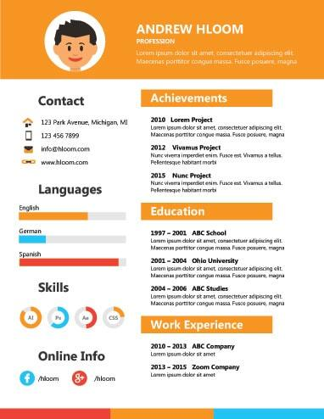

  - Use Time tag to display your birthdate in your CV.
  - Try to make your page is responsive in any screen size (Use viewport meta tag and use relative sizing).

- In assignment No.1, Use hidden audio element (without controls), that plays ringing sound when mouse is over contact section, and stop it when the mouse is away (You can search for a sound here: https://www.soundsnap.com/search/audio ).
- In Assignment No.1, use video element to display a video about you in your page.
- Make a page that has a button that when clicked gets your location and show it on google maps on a new window (Use HTML5 GeoLocation).

Bonus Assignments:
- Use HTML5 drag and drop, to make the following assignment:
Make a div with width and height: 100px, and make a border and background color for it, and make an image that can be dragged and dropped on the div.
  - Make 3 images and make the div allowing drop of specific image only.
  - Change the div background when the image is dropped over it.
- Refer to the following links for Meter tag styling and tricks:
https://css-tricks.com/html5-meter-element/
https://www.hongkiat.com/blog/style-html5-meter/
- Design a home page for yourself using HTML5 structural elements, and use the following layout:
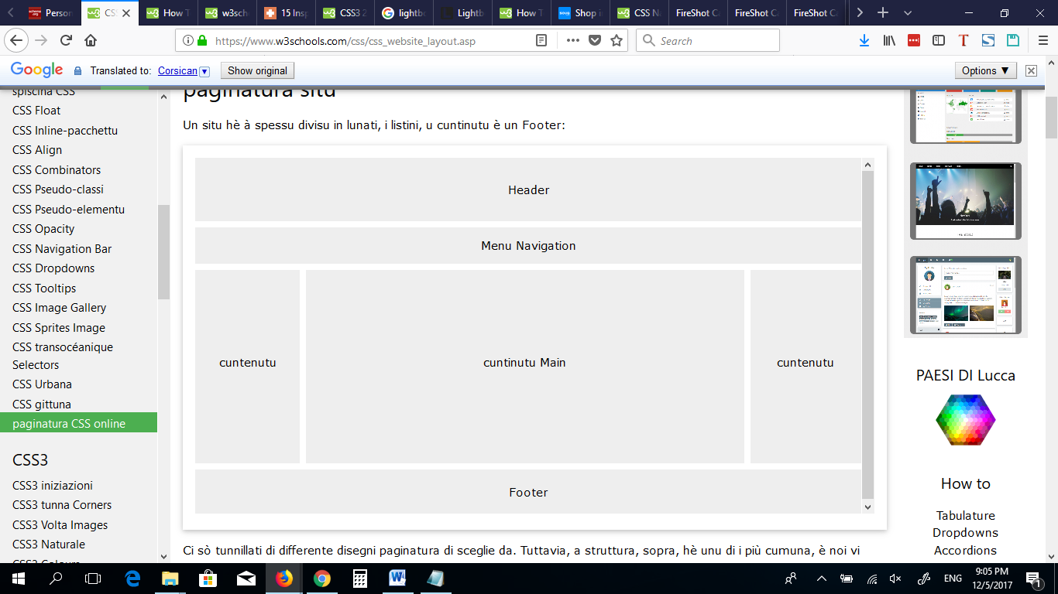
- In previous Assignment, use MicroData with your personal info in your CV, and use Google Structured Data Testing Tool: (http://www.google.com/webmasters/tools/richsnippets) to test it.

- Search for the following HTML5 new features, and make a demo on them:
  - HTML5 App Cache
  - HTML5 Web Workers
  - HTML5 Drag&Drop
  - HTML5 Server Sent Events.
  - HTML5 Fallback and Polyfills
  - Html5 Script Loader

- Search for HTML 5, 6 new features
- Innovate in your CV and add other attractive content to it.
- In the given tiger Demo, paly a sound when the tiger arrives to the end of the page.
- Search for HTML5 new tags and use it and use it.
- Search for CSS3 new features and use it.

<Thank>YOU </Thank>

